**Making the playbook work on multiple distributions**

* In this series let’s try to make spring pet clinic work on Centos 7 as well
* The manual steps are almost the same as what we have done for ubuntu apart from jdk installation

sudo yum install java-11-openjdk -y

* <https://github.com/asquarezone/AnsibleZone/commit/671927bb0a489d08272b7b47da31c6e193b24af9> for the changes made 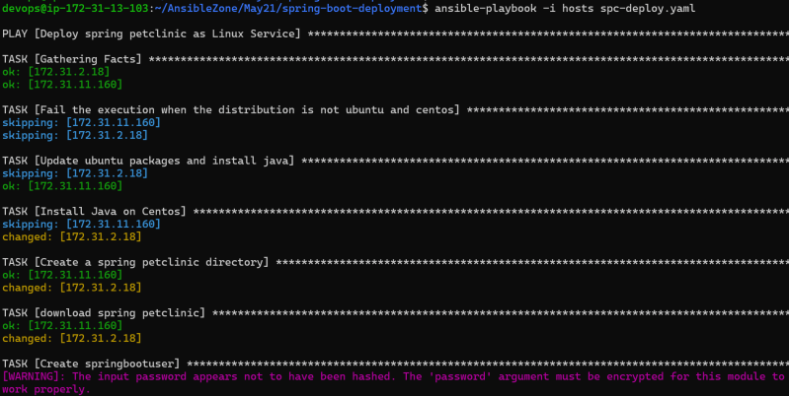
* Using generic package module

**Lets Try to Create ansible playbook to install lamp stack**

* Manual steps of ubuntu:

sudo apt update

sudo apt install apache2 -y

sudo apt install php libapache2-mod-php php-mysql php-cli -y

# Create a file with content <?php phpinfo(); ?>

/var/www/html/info.php

sudo systemctl restart apache2

* Manual steps for centos 7

sudo yum install httpd -y

sudo systemctl enable httpd

sudo yum install php php-mysql php-fpm -y

# Create a file with content <?php phpinfo(); ?>

/var/www/html/info.php

sudo systemctl restart httpd

* [Refer Here](https://github.com/asquarezone/AnsibleZone/commit/63a4c9c8cce0bfb03b8245dea9a043ea6e5d22aa) for the play book created for installing apache server with php packages 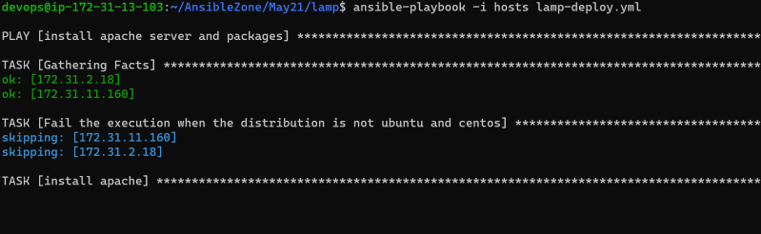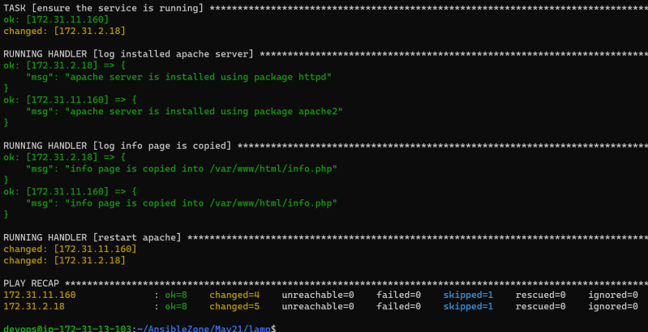

**Lets try to write a ansible playbook to install tomcat 9 on ubuntu 18.04**

* Link: https://www.digitalocean.com/community/tutorials/install-tomcat-9-ubuntu-1804
* Install Java on ubuntu 1804

1 sudo apt update

2 sudo apt install openjdk-11-jdk -y